Batch: A3 Roll No.: 1911034

Experiment No. 2

Grade: AA / AB / BB / BC / CC / CD /DD

Signature of the Staff In-charge with date

TITLE: Implement the program for validating username and password.

AIM: Implement the program for validating username and password.
______________________________________________________________________
Expected OUTCOME of Experiment:

CO 1- Describe the Numbers, Math functions, Strings, List, Tuples and Dictionaries in
Python
CO 2 - Interpret Different Decision Making statements, Functions, Object oriented programming in Python
_____________________________________________________________________
Books/ Journals/ Websites referred:

- Core Python Applications Programming by Wesley J Chun
- https://www.tutorialspoint.com/python/index.htm

_____________________________________________________________________
Pre Lab/ Prior Concepts: Data structures are a way of organizing and storing data so that they can be accessed and worked with efficiently. They define the relationship between the data, and the operations that can be performed on the data. There are many various kinds of data structures defined that make it easier for the data scientists and the computer engineers, alike to concentrate on the main picture of solving larger problems rather than getting lost in the details of data description and access.
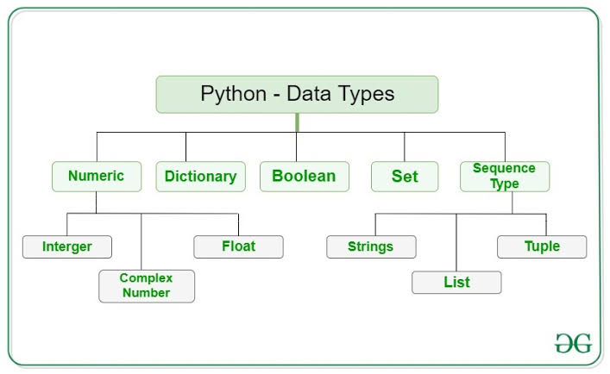
There are quite a few data structures available. The built-ins data structures are: lists, tuples, dictionaries, strings, sets and frozen sets.

Theory for Functions used to implement the given problem statement
isupper() :The isupper() method returns True if all the characters are in upper case, otherwise False.
Numbers, symbols and spaces are not checked, only alphabet characters.
islower() : In Python, islower() is a built-in method used for string handling.
The islower() methods returns “True” if all characters in the string are lowercase, Otherwise, It returns “False”.
isdigit(): The isdigit() method returns True if all the characters are digits, otherwise False.
Exponents, like ², are also considered to be a digit.

Problem Statement: (part 1)
Write a program to accept the users input for username and password to register. Write a program to check the validity of Username and password input by users.
Following are the criteria for checking the password:
1. At least 1 letter between [a-z]
2. At least 1 number between [0-9]
1. At least 1 letter between [A-Z]
3. At least 1 character from [$#@]
4. Minimum length of transaction password: 8
5. Maximum length of transaction password: 15
Your program should accept a sequence of comma separated passwords and will check them according to the above criteria. Passwords that match the criteria are to be printed, each separated by a comma.
Note: Unique username, valid password based on rules.
signup and then go for sign in checking with 2 or 3 attempts.
Program: (Attach file)
passwords = (input("enter the passwords to be checked, seperated by a comma "))
list1=passwords.split(',')
print("The list of passwords entered is as follows: ")
print(list1)
print("The list of passwords that satisfy the given conditions are as follows: ")
for x in list1:
ch=[0,0,0,0]
flag=0
for t in x:
if (t.islower()):
ch[0]=1
continue
elif (t.isupper()):
ch[1]=1
continue
elif(t=='$'or t=='#' or t=='&'):
ch[2]=1
continue
elif (t.isdigit()):
ch[3]=1
continue
else:
continue

for m in ch:
if m==0:
flag=1 #if any of the conditions is not satisfied the password is incorrect.
#flag1 checks each character of the array
break
if flag==0:
if(len(x)>=8 and len(x)<=15):
print(x)

Output: (Screenshot of Sample Output)

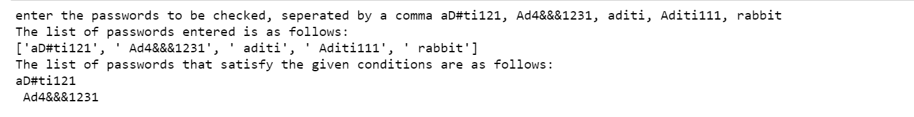

Problem Definition (Part 2)
1.Sign up(for new users)
Accept User and Password
Check the Conditions for Successful Password
2.Sign in(for existing users)
Accept username
Check whether Username exists or not
Accept Password
Check whether Password matches with the Password in the database or not
3.Exit
Please enter your choice:
Program (Part 2)
ch1=int(input("enter number of users for signin/ signup "))
usn=[]
pws=[]
for i in range (0,ch1):

print("***********************************************************************************")

ch = int(input("enter 1 to sign up (for new users) or 2 to sign in (for existing users) "))

if ch==1:
n_us = input("enter the username ")
flag1=0
for x in usn:
if x==n_us:
print("username already exists. Try again ")
flag1=1 #flag1 is used to indicate that the username cannot be appended because another same already exists
break

if flag1==0:
usn.append(n_us)
else:
continue #continue is used to skip the current iteration of the loop as the username is invalid
x= input("enter the password ")
ch=[0,0,0,0]
flag=0
flag3=0
for t in x:
if (t.islower()):
ch[0]=1
continue #continue will check the next character as the current character has already
#satisfied one of the conditions
elif (t.isupper()):
ch[1]=1
continue
elif(t=='$'or t=='#' or t=='&'):
ch[2]=1
continue
elif (t.isdigit()):
ch[3]=1
continue
else:
continue

for i in range(0,len(ch)):
if ch[i]==0:
if i==0:
print("password must have atleast one lowercase letter")
flag=1 #flag checks even if one of the conditons is not satisfied , account can't be created.
elif i==1:
print("password must have atleast one uppercase letter")
flag=1
elif i==2:
print("password must have atleast one symbol from #,&,$")
flag=1
elif i==3:
print("password must have atleast one digit")
flag=1
i=i+1

if flag==0:
if len(x)>=8 and len(x)<=15:
print("account created successfully")
pws.append(x)
else :
print("account not created")
usn.pop()
else:
print("account not created")
usn.pop()

elif ch==2:
index1 =0
flag2=0
u1 = input("enter the username ")
for y in usn:
if y==u1:
print("account found!")
index1 = usn.index(y)
flag2=1
break
if flag2==0:
print("no such account exists")
else:
passw= input(print("enter the password for your acount"))
if pws[index1]==passw:
print("login successful!")
else :
print("wrong password")

Sample Output (Part 2)
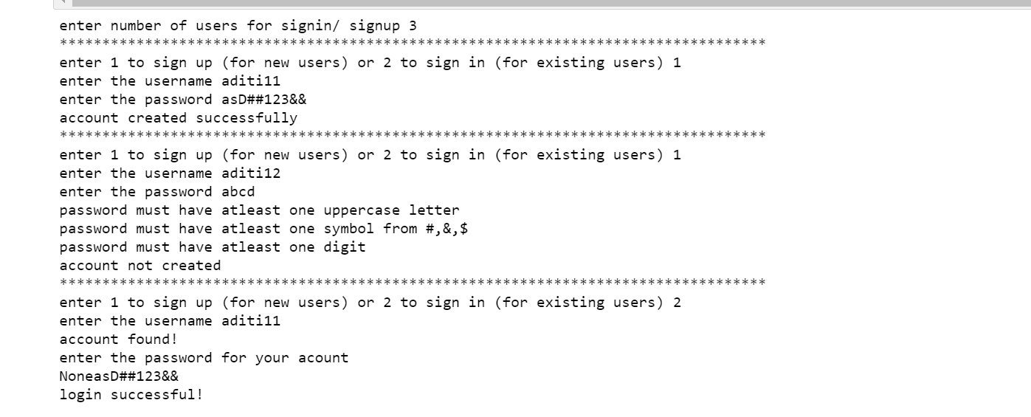

Conclusion: In this experiment we have successfully applied the concepts of different kinds of checking functions such as isupper() , islower() etc , as well as the knowledge of lists to accept a list of passwords and store them , also we have been able to ask users for signin/signup.
Date: _____________ Signature of faculty in-charge

Post Lab Descriptive Questions
What will be the output of the following statements?
- str='python'
print (str.center(15,'*'))
Output: *****python****

- str='abbabadaadbbaccabc'
print(str.count('ab',2))
Output : 2

- str='PYTHON\nString\nConcepts'
print (str.splitlines())
Output: ['PYTHON', 'String', 'Concepts']

- print ('+55'.zfill(5))
Output:
+0055
- str='abcdefcdyzcd'
print (str.split('cd',2))
Output:
['ab', 'ef', 'yzcd']

- str='abcdefcdyz'
print (str.partition('cd'))
Output: ('ab', 'cd', 'efcdyz')

